Your Name: STEPHEN OMONDI  
Your SUID: 946934043  
Your Email: SOOMONDI@SYR.EDU  
Date Due: 2019-11-23  
Homework #: LABWORK 8

# Exercises

Complete each of the following exercises. If you are unsure how to accomplish the task, please consult the coursework videos where there are explanations and demos.

1. Write a MongoDB Query to retrieve Country name, population, and capital for all countries in the collection.

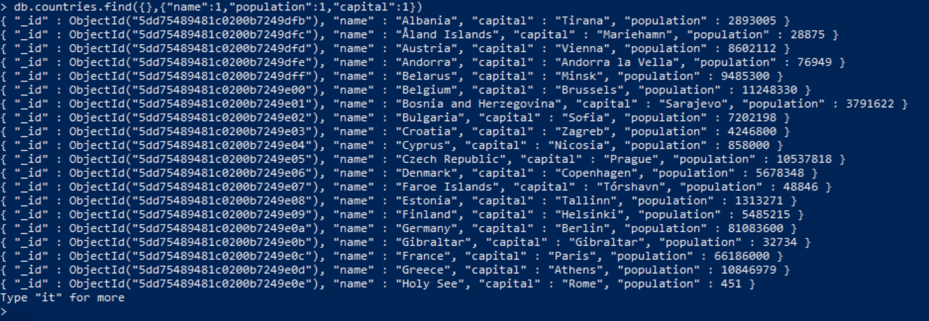

1. Write a MongoDB Query to retrieve Country name, population, and capital for all countries with a population under 500,000 sorted by population.

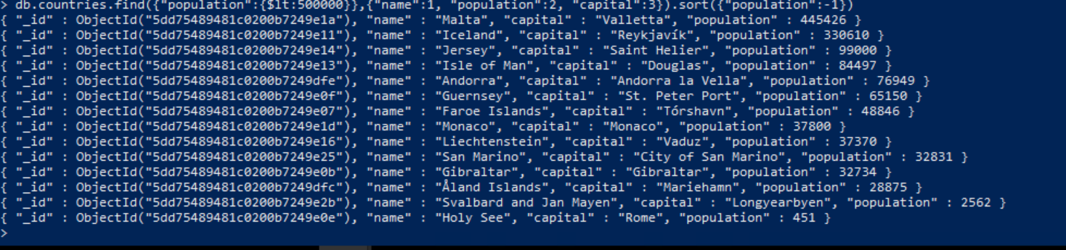

1. Use the**. explain(“executionStats”)** method to analyze the query you wrote in the previous step. Write an index to improve the performance of the query, then perform another explain to demonstrate it worked. Include the code of the index you wrote, the and the relevant output of the execution stats which demonstrate the index is being used.

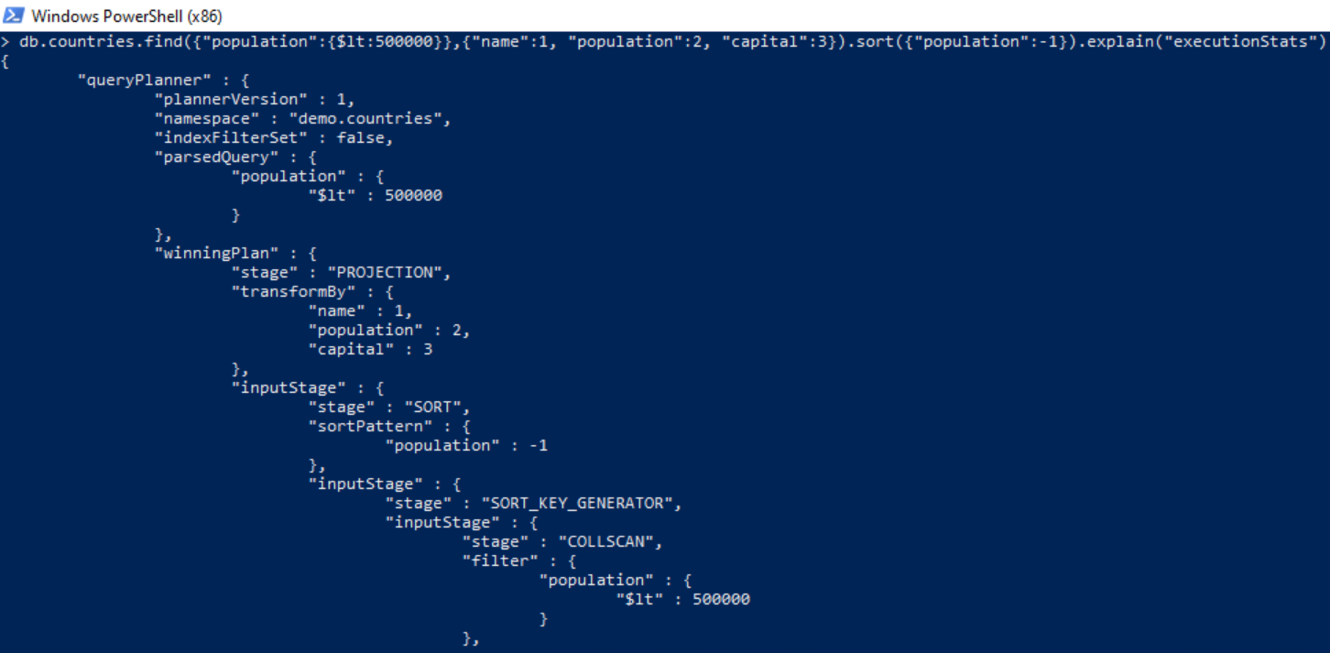

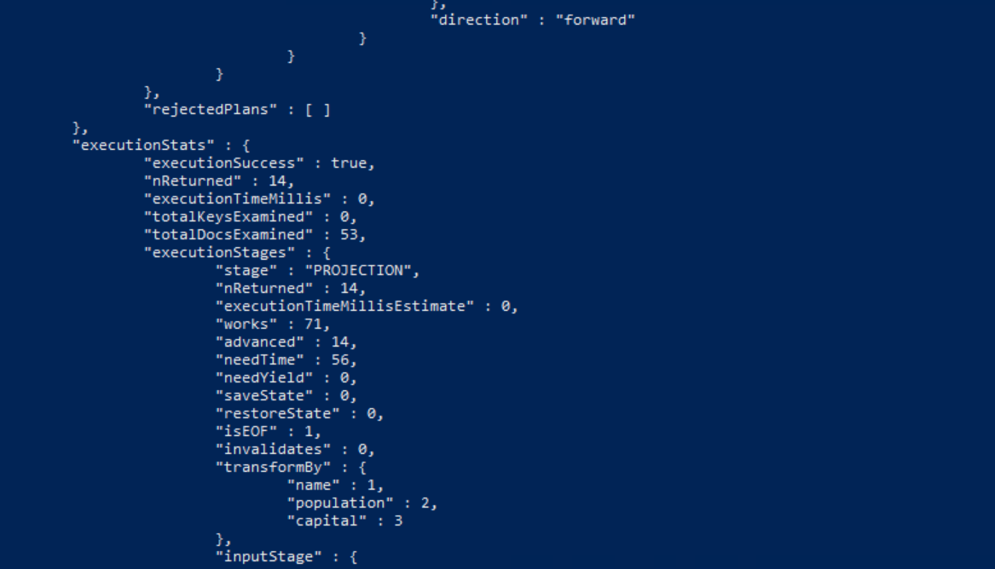

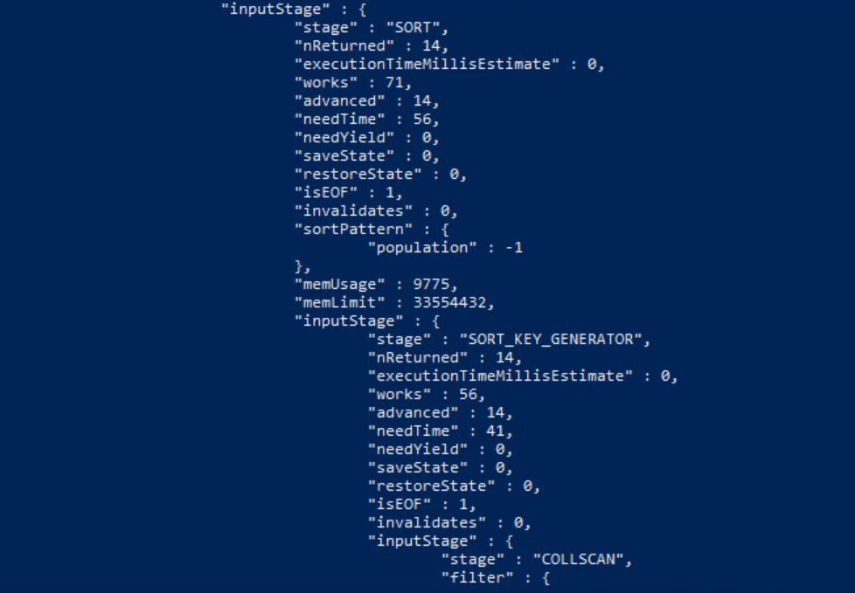

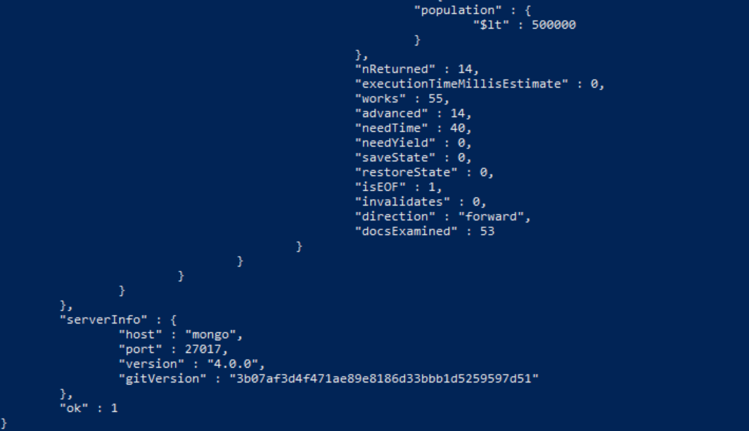

It shows that a COLLECTION SCAN was used which looked though all 53 documents in the collection.

We can improve this by indexing as shown below:

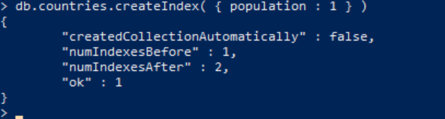

Running the query above again:



Part of the results shown below:

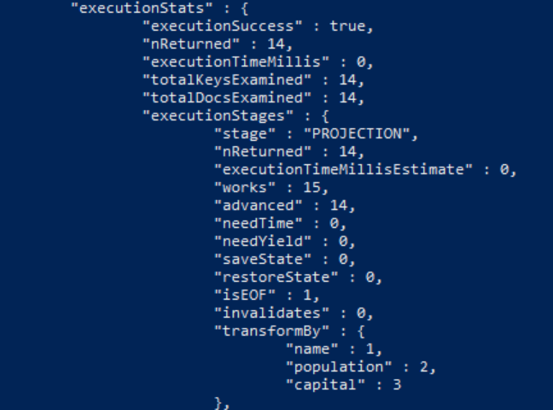

The search shows that only 14 documents were examined rather than 53 using IXCAN. This shows that the index on POPULATION worked.

1. Select the most appropriate Redis data structure to store the following information:

|  |  |  |  |
| --- | --- | --- | --- |
| Product ID | Name | Qty On Hand | Unit Price |
| 1 | Apple | 7 | 2.49 |
| 2 | Banana | 12 | 1.99 |
| 3 | Cherry | 9 | 4.99 |

Execute the commands to store this information in Redis. Make sure to namespace your key and each of the fields should be retrievable under the key used.

Storing the values

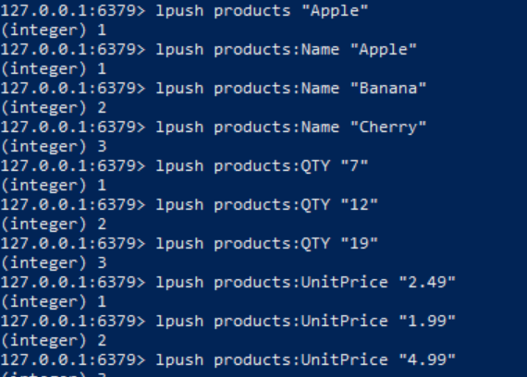

**Retrieving the values**

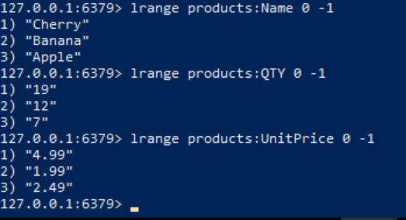

1. Select the most appropriate Redis data structure to store the following information:

The 2018 Golden Snowball Competition for the Upstate NY City with the Highest Snowfall. Scores updated hourly.

|  |  |  |  |
| --- | --- | --- | --- |
| City | Syracuse | Rochester | Buffalo |
| Snowfall Inches | 97 | 68 | 84 |

Execute the commands to store this information in Redis. Make sure to namespace your key and each of the snowfall values should be updatable. For example, you should be able to add 10 inches to Buffalo to make it 94. You should be able to display the information upon request.

**Storing the information:**

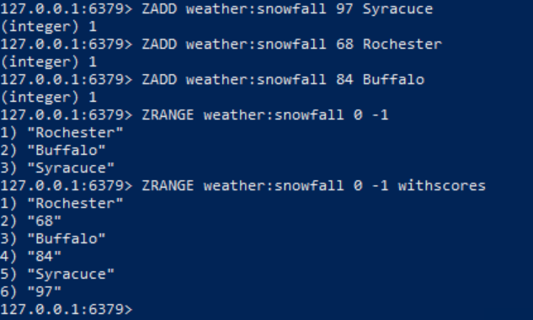

**Updating the information:**

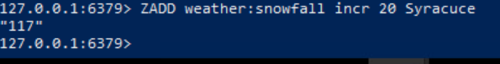

Shows the snowfall increase from 97 to 117 for Syracuse.